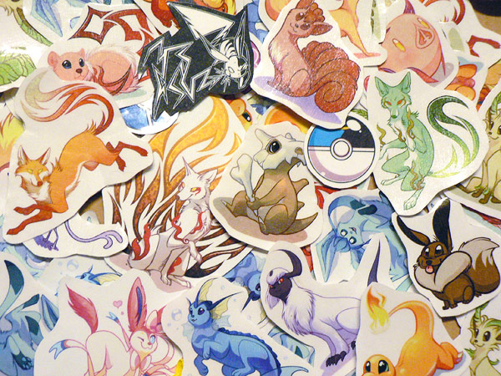

**FEATHER CRITTER’S**

**STICKERS!**

**STEP ONE:** Enter the quantity of each sticker you would like in the quantity box (yellow) next to the sticker you want.

**If you would like the totals to update,** highlight the total and press the “F9” button, OR select the entire document by pressing “CTRL” and “A” together (PC) or “http://km.support.apple.com/library/APPLE/APPLECARE_ALLGEOS/HT1343/ks_command.gif” and “A” together (Mac) and then press the “F9” button. (not required, I can do this for you later)

**STEP TWO:** Enter your shipping address in the boxes provided and select either USA or International shipping by entering “1” or “5” in the shipping box

**STEP THREE:** Save and email this form as an attachment to [**feathercritter@gmail.com**](mailto:feathercritter@gmail.com) and wait for me to get back to you!

Hand-made stickers are printed on label paper and sealed with contact paper to protect them and give them a glossy appearance. Colors may vary slightly from catalog image. Most character stickers are 2-3 inches. The Progfox is slightly larger at 3.5 inches. The Pokeballs are approximately 1 inch.

**POKEMON**

|  |  |  |  |
| --- | --- | --- | --- |
| Sticker | Price | Quantity | Sticker total |
| vulpixthumb.jpg  Vulpix | 0.75 | 0 |  |
| charmanderthumb.jpg  Charmander | 0.75 | 0 |  |
| cutiebonethumb.jpg  Cubone | 0.75 | 0 |  |
| fennekinthumb.jpg  Fennekin | 0.75 | 0 |  |
| absolthumb.jpg  Absol | 0.75 | 0 |  |
| scytherthumb.jpg  Scyther | 0.75 | 0 |  |
| eeveethumb.jpg  Eevee | 0.75 | 0 |  |
| flareonthumb.jpg  Flareon | 0.75 | 0 |  |
| vaporeonthumb.jpg  Vaporeon | 0.75 | 0 |  |
| joltwip.jpg  Jolteon (pre-order; your stickers will ship when this design is complete) | 0.75 | 0 |  |
| umbreonthumb.jpg  Umbreon | 0.75 | 0 |  |
| leafenthumb.jpg  Leafeon | 0.75 | 0 |  |
| glaceonthumb.jpg  Glaceon | 0.75 | 0 |  |
| sylveonthumb.jpg  Sylveon | 0.75 | 0 |  |
| Pikachuthumb.jpg  Pikachu | 0.75 | 0 |  |
| umbreonoldthumb.jpg  Umbreon (old design) | 0.75 | 0 |  |
| espeonoldthumb.jpg  Espeon (old design) | 0.75 | 0 |  |
| # of Pokemon stickers | 0 | Pokemon stickers total: | 0.00 |

**POKEBALLS**

**$0.30**

|  |  |  |  |  |
| --- | --- | --- | --- | --- |
| pokethumb.jpgPokeball | greatthumb.jpgGreat Ball | ultrathumb.jpgUltra Ball | masterthumb.jpgMaster Ball | divethumb.jpgDive Ball |
| 0 | 0 | 0 | 0 | 0 |
| friendthumb.jpgFriend Ball | moonthumb.jpgMoon Ball | quickthumb.jpgQuick Ball | premierethumb.jpgPremiere Ball | dreamthumb.jpgDream Ball |
| 0 | 0 | 0 | 0 | 0 |
| luxthumb.jpgLuxury Ball | lovethumb.jpg  Love Ball | rocketthumb.jpgRocket Ball | # of Pokeball stickers | Pokeball stickers total |
| 0 | 0 | 0 | 0 | 0.00 |

**NOISE**

|  |  |  |  |
| --- | --- | --- | --- |
| psychedelifoxthumb.jpg  Psychedelifox | 0.75 | 0 |  |
| ambiefoxthumb.jpg  Ambiefox | 0.75 | 0 | 0.00 |
| progfoxthumb2.jpg  Progfox (3.5 inches) | 1.00 | 0 | 0.00 |
| rhymethumb.jpg  Precious Baby Squirrel Child | 0.75 | 0 | 0.00 |
| pigsambathumb.jpg  Pig Samba | 0.75 | 0 | 0.00 |
| pigchachathumb.jpg  Pig Cha-Cha | 0.75 | 0 | 0.00 |
| symphonifoxthumb.jpg  Symphonifox | 0.75 | 0 |  |
| industriafoxthumb.jpg  Industriafox | 0.75 | 0 |  |
| Number of Noise stickers | 0 | Noise stickers total | 0.00 |

|  |  |
| --- | --- |
| Total number of Stickers |  |
|  |  |
| Subtotal: |  |
| Shipping: Enter “1” for USA or “5” for international. | 1 |
| Total in USD: |  |

**Shipping address:**

|  |  |
| --- | --- |
| Name: |  |
| Address: |  |
| City, state, zip, etc |  |
| Country: |  |

|  |  |
| --- | --- |
| CUSTOM POKEMON OR NOISE  cutomfennecthumb.jpg  **Want a Pokemon or Noise you don't see? Commission it!** | * I get to choose pose and expression * You can add custom colors, accessories, etc. * You get a high-resolution image file and a free sticker! * I can transform any character into a Pokemon or Noise! * I will make a normal version to add to my sticker roster. (ex, the normal colored Fennekin was created from this commission) * No totally original Pokemon/Noise on the discounted rate, sorry! (I'll take them as regular commissions though!) * Also accepting Dream Eaters, Heartless, etc. (Kingdom Hearts) and canon MLP characters   $25-45 depending on complexity  ($25 for something like Vaporeon or Pig Samba, $45 for something like Mega Sceptile or Skelterwild)  Custom Pokeballs $5-15  Email me if you'd like to get a custom! |