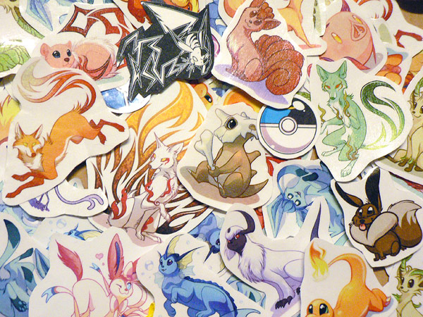
FEATHER CRITTER’S
STICKERS!
STEP ONE: Enter the quantity of each sticker you would like in the quantity box (yellow) next to the sticker you want.
STEP TWO: Enter your shipping address in the boxes provided and select either USA or International shipping by entering “1” or “5” in the shipping box
STEP THREE: Save and email this form as an attachment to feathercritter@gmail.com and wait for me to get back to you!

Hand-made stickers are printed on label paper and sealed with contact paper to protect them and give them a glossy appearance. Colors may vary slightly from catalog image. Most character stickers are 2-3 inches. The Progfox is slightly larger at 3.5 inches. The Pokeballs are approximately 1 inch.

POKEMON
Sticker | Price | Quantity | Sticker total
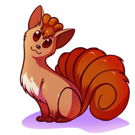  Vulpix | 0.75 | 0 | 0.00
  Charmander | 0.75 | 0 | 0.00
  Cubone | 0.75 | 0 | 0.00
  Fennekin | 0.75 | 0 | 0.00
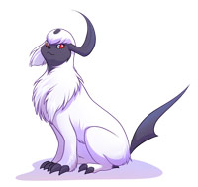  Absol | 0.75 | 0 | 0.00
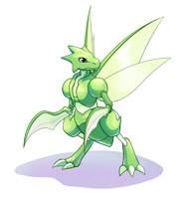  Scyther | 0.75 | 0 | 0.00
  Eevee | 0.75 | 0 | 0.00
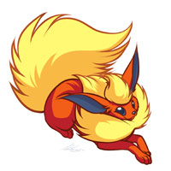  Flareon | 0.75 | 0 | 0.00
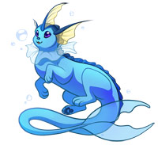  Vaporeon | 0.75 | 0 | 0.00
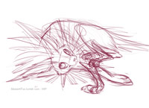  Jolteon (pre-order; your stickers will ship when this design is complete) | 0.75 | 0 | 0.00
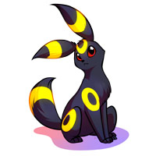  Umbreon | 0.75 | 0 | 0.00
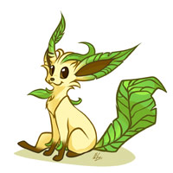  Leafeon | 0.75 | 0 | 0.00
  Glaceon | 0.75 | 0 | 0.00
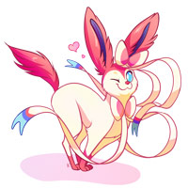  Sylveon | 0.75 | 0 | 0.00
  Pikachu | 0.75 | 0 | 0.00
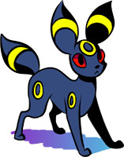  Umbreon (old design) | 0.75 | 0 | 0.00
  Espeon (old design) | 0.75 | 0 | 0.00
# of Pokemon stickers | 0 | Pokemon stickers total: | 0.00

POKEBALLS
$0.30
  Pokeball | 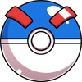  Great Ball |   Ultra Ball | 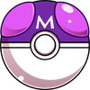  Master Ball |   Dive Ball
0 | 0 | 0 | 0 | 0
  Friend Ball |   Moon Ball |   Quick Ball | 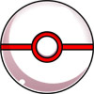  Premiere Ball | 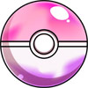  Dream Ball
0 | 0 | 0 | 0 | 0
  Luxury Ball |   Love Ball |   Rocket Ball | # of Pokeball stickers | Pokeball stickers total
0 | 0 | 0 | 0 | 0.00

NOISE

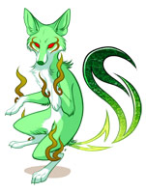  Psychedelifox | 0.75 | 0 | 0.00
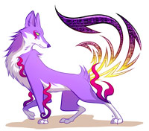  Ambiefox | 0.75 | 0 | 0.00
  Progfox (slightly larger sticker) | 1.00 | 0 | 0.00
  Squirrel | 0.75 | 0 | 0.00
  Pig Samba | 0.75 | 0 | 0.00
  Pig Cha-Cha | 0.75 | 0 | 0.00
  Symphonifox | 0.75 | 0 | 0.00
  Industriafox | 0.75 | 0 | 0.00
Number of Noise stickers | 0 | Noise stickers total | 0.00

Total number of Stickers | 0
Subtotal: | 0.00
Shipping: Enter “1” for USA or “5” for international. | 1
Total in USD: | 1.00

Shipping address:
Name:
Address:
City, state, zip, etc
Country:

CUSTOMIZED POKEMON OR NOISE  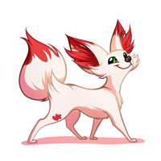  Want a Pokemon or Noise you don't see? Commission it! | - I get to choose pose and expression  - You can add custom colors, accessories, etc.  - You get a high-resolution image file and a free sticker!  - I can transform any character into a Pokemon or Noise!  - I will make a normal version to add to my sticker roster. (ex, the normal colored Fennekin was created from this commission)  - No totally original Pokemon/Noise on the discounted rate, sorry! (I'll take them as regular commissions though!)  - Also accepting Dream Eaters, Heartless, etc. (Kingdom Hearts) and canon MLP characters  $25-45 depending on complexity  ($25 for something like Vaporeon or Pig Samba, $45 for something like Mega Sceptile or Skelterwild)  Custom Pokeballs $5-15  Email me if you'd like to get a custom!

